ETHNOGRAPHY OF COMMUNICATION IN ARABIC LANGUAGE LEARNING

Rudiny
MA Ubudiyah Bati-Bati, Kalimantan Selatan
Corresponding.E-Mail: rudinyindis@gmail.com

Abstract.
This research was the Ethnography of Communication in Arabic learning to students MA Ubudiyah Bati-Bati. This study started from the author's initial observation about the tradition of many of the 12th-grade students in Arabic learning communication at MA Ubudiyah Bati-Bati found language traditions. These traditions were unique in communication between teachers to students, students to students, and students to teachers. As with the diverse ethnic backgrounds of students. Based on the statement above, the results of this study indicate that educational experience, ethnicity, place of residence, and language use of these affect students' communication style in the classroom. Furthermore, in this study, students used 5 languages ​​in communication in the classroom: Arabic, Banjarese, Indonesian, English, and Javanese. Then the speech patterns of student interactions in this study amounted to 16 patterns of interaction speech used. A pattern in the exchange of learning Arabic. Produces this pattern more from teachers to students because, in it, there are questions and answers. For students to students, there are only a few because they do not have much time to talk to their friends in the class room when learning Arabic. In addition from the results of the analysis of interactions that occurred in learning Arabic, the researchers found 3 words that were often spoken during the learning process until students became accustomed to saying them. That is, “Bujurlah pa”, “Insya Allah”, and “Izin bertanya/izin menjawab”.

Keywords: Ethnography of Communication and Learning Arabic

Introduction
The Indonesian nation is famous for its people who have diverse cultures. In each region, our society develops its own culture. A culture that is developed in these areas is called local culture. Human culture has seven universal elements of culture. The seven elements are the religious system, the social system, the knowledge system, the language system, the art system, the livelihood system, and the technology system.
Ethnography is an ethnic culture. However, because in this world there are small ethnic groups consisting of only a few hundred inhabitants but there are also large ethnic groups consisting of millions of people, then an ethnography of course cannot cover all of the large ethnic groups. The cultural unity of ethnic groups in a community from an ecological geographic area or in a certain administrative area becomes the subject of an ethnography.
Humans are social creatures and need relationships with other people. It is through communication that humans can relate to other people. communication can be done orally and in writing, signs, and symbols. Communication is carried out both traditional and modern with tools ranging from the simplest to the most sophisticated and sophisticated. Communication is effectively sending and receiving information or messages between two or more people so the intended message can be understood. In the delivery or receipt of information there are two parties involved, namely: (1) Communicator: Person/group of people who convey information or messages; (2) Communicator: person or group of people who receive the message. In communicating the success of the communicator or communicant is largely determined by several factors, namely: Proficiency, Knowledge, Attitude, Social System, and Outer Condition.
In Indonesia, Arabic is one of the subjects taught in primary schools and middle and high schools through universities. Arabic is one of the most distinctive subjects of religiously oriented schools and has more value than in public schools. This advantage makes the enthusiasm of community to enroll their children in religious education institutions. Arabic belongs to the Semitic language family of African-Asian origin. Arabic has an important role for Muslims because it is the language of the Koran, Hadith, and the language of the people of Heaven.[1] Therefore, learning Arabic is important in Religious schools.
The teacher is a member of the community who is competent and gains the trust of the community and or the government to carry out his duties, functions, and roles, namely teaching, educating and guiding, and demanding students in learning or, in other words, the teacher is one of the human components in the formation of human resources. etc. Meanwhile, a student is anyone who receives an understanding from a person or group of people who carry out educational activities.
Both teachers and students are important elements in the learning process. Because they are the ones who carry out the learning process. The learning process will not occur if there are no teachers or students. By looking at the notion that education is a conscious effort from teachers that aims to develop the quality of students, there is a meaning that the process called education will never take place if there are no teachers and students present in a series of teaching and learning activities. So it can be said that teachers and students are the main pillars of the implementation of educational activities. The role of an educator is very important during the teaching process to students (the main one).
Language is important in learning because in principle this activity focuses on how to move humans/learners to carry out learning activities. Language becomes a conveying tool so that learning reaches a certain point as a predetermined competency. As the owner of language in communicating, some of the elements in learning place humans as the main element, while other elements are complementary to being able to express language in learning communication. Existing elements other than humans include messages or learning content, learning methods, learning media, and learning hardware.
Language is one of the fundamental factors that distinguish humans from animals. Language as a gift from the creator allows individuals to live together with others, help solve problems and position themselves as cultural beings. Language is a means of communication with other people. In this sense, it includes all ways to communicate, in which thoughts and feelings are expressed in spoken, written, gesture, or gestured form using words, symbols, symbols, pictures, or paintings. Language is a means of communication with other people. Language can also be used to convey information about different places or different times.
Through culture, people learn communication. The ways we communicate, the circumstances in which we communicate, the language and style of language used, and non-verbal behavior are all primarily a response to and a function of culture. As cultures differ from one another, the communication practices and behavior of individuals raised in certain cultures will also differ. Difficulty communicating with other people, especially those from different cultures, is not only a difficulty in understanding their language but also their value system and nonverbal language. Non-verbal language anywhere is more dominant than verbal language. Therefore, communication that is not sensitive to the value system adopted by a cultural community can lead to disputes.
Cultural behavior that originates from the original cultural identity should determine the language and communication behavior used by the person, and be able to distinguish it from the behavior of other people with different cultures. That is, a person backgrounds their respective cultural different characteristics from other people with different cultures. According to Henri Tajfel and John Turner as the founders of Social Identity Theory which defines social identity as individual knowledge in which a person feels as a member of a group that has the same emotions and values.
In the communication of learning Arabic at MA Ubudiyah Bati-Bati, there is a tradition of language. That tradition is unique in communication both teacher to student, student to student, and student to teacher, as the different ethnic backgrounds of students. As the current situation is during the COVID-19 pandemic, the school continues to meet face-to-face by always carrying out health protocols.
Communication is done every day when at home, at the market, at school, on social media and others. This research is devoted to the classroom, because there is communication related to teaching and learning activities. Teaching and learning activities are always a process of interaction between two human elements in which students are the ones who learn and teachers are the ones who teach. The process itself is a link that connects teachers and students so that communication that has a purpose is developed, namely learning objectives. Therefore, the researcher here wants to try to examine how the ethnography of communication in learning Arabic at MA Ubudiyah Bati-Bati occurs. Based on the problems above, here I will raise the theme of Ethnography of Communication in Arabic Learning for MA Ubudiyah Bati-Bati Students.
Method
Ethnography as part of a sub-discipline focuses more on the relationship of social groups or cultural actors with their interactions. This social group is a collection of individuals who are intertwined and interact through the collective subject of society. According to Hymes, ethnography is not a language, but is a communication that provides a frame of reference about the position of language in the culture and society to be explained. This study aims to describe ethnographically, the communication between students and teachers of MA Ubudiyah Bati-Bati, in Arabic learning communication. To achieve this goal, the researchers used this type of field research. The ethnographic method of communication is an ethnographic method that is applied to see communication patterns.
There are three basic methodological principles of ethnographic research. The first principle is naturalism, namely the principle that captures the character of human behavior that appears in natural settings (settings that give freedom to the research process, not settings specifically made by researchers for research or experimental purposes). The second principle is understanding, namely the principle that studies the character of the research subject before explaining his behavior. The third principle is discovery, namely the conception of the research process as inductive or based on findings.
In communication ethnography, the focus of attention is what individuals in a society do or behave, then what they talk or discuss and there is a relationship between behavior and what should be done in that society or the conclusion is the overall behavior in a particular cultural theme. As for what is meant by communication behavior according to communication science is the action or activity of a person, group or activity of a person, group or audience when involved in the communication process.
Ethnography is a form of research that focuses on the meaning of sociology through field observations of sociocultural phenomena. This research requires the researcher's participatory observation and written description. This study uses three methods of providing data, namely: observation; deep interview; and structured interviews. First, the observation method that the researcher uses is by observing the object of study in its context. This method is also known as the see method.
This method uses field notes by coding each Arabic learning event. The first and second codes are numbers that indicate the class of students in the learning interaction, namely; 1. class X; 2. class XI; and 3. class XII. The next code is a letter that marks the interaction event, namely A vocabulary learning event, B listening learning, C speaking learning, D reading learning and E Qowaidul Lughah learning. The eight codes after the letters represent the date of the interaction event until it becomes a series of codes (02)1C03022021. Second, the in-depth interview method, which the researcher uses to complete and deepen the data information that the researcher obtains through observation. Third, structured interviews, researchers used to reveal the characteristics of the main research subject (students at MA Ubudiyah Bati-Bati). The researcher looked at the students from the factors of ethnicity, gender, age, place of residence, education, linguistic background, and their motivation to learn Arabic.
Result and Discussion
- Characteristics of Students
Character is a set of traits that are always admired as signs of a person's goodness, virtue, and moral maturity. Etymologically, the term character comes from the Latin character, which means character, character, personality, psychological traits, character, and morals. Characteristics of a person can not be separated from the culture. The word ethnography comes from the Greek, namely ethnos and graphein. Ethnos (nation) means people or folk, while graphein (to describe) refers to the depiction of something. Therefore, ethnography is a description of a culture or way of life of people in a particular community. More specifically, ethnography seeks to understand human behavior when they interact with each other in a community.
Character is good typical values ​​(knowing the value of goodness, willing to do good, really living a good life, and having a good impact on the environment contained within and manifested in behavior. In relation to education, character education can be interpreted as value education, character education, moral education, and character education, which aims to develop students' abilities to make good and bad decisions, maintain goodness, and realize and spread goodness in everyday life wholeheartedly. Character education is based on basic human characters, which are sourced from universal moral values ​​(absolute in nature) as the embodiment of religious values ​​commonly called the golden rule. Character education can have definite goals if it is based on these basic character values.
This Madrasah Aliyah Ubudiyah Bati-Bati student has 3 majors, namely: Natural Sciences Mathematics (MIA), Social Sciences (IIS) and Religious Sciences (IIK). Based on ethnicity, gender, age, place of residence, educational background, and motivation to learn Arabic.
- Students of Mathematics and Natural Sciences (MIA)
Class XII students of Mathematics and Natural Sciences in the class have 17 students, 9 male students and 8 female students. There are 2 male students who are Dayak and the rest are Banjarese. The average age of students in this class is about 18 years and reside not too far from the madrasa. Then their educational background is from junior high school, about 2 students, the rest are from Madrasah Tsanawiah and Pondok Pesantren. See the diagram below:
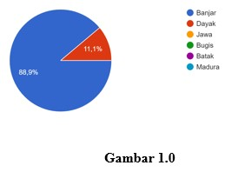

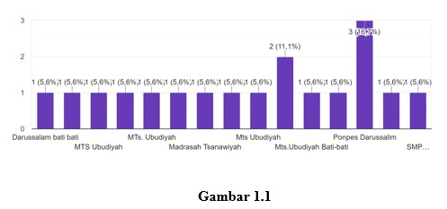

- Students of Social Sciences Department (IIS)
Students of class XII majoring in Social Sciences in this class have 35 students, 17 male students and 18 female students. There are 1 Dayak student, 1 Bugis student and 3 Javanese students and the rest are Banjarese. The average age of students in this class is about 18 years and reside not too far from the madrasa. Then their educational background is from junior high school, about 2 students, the rest are from Madrasah Tsanawiah and Pondok Pesantren. See the diagram below:
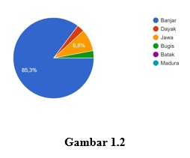
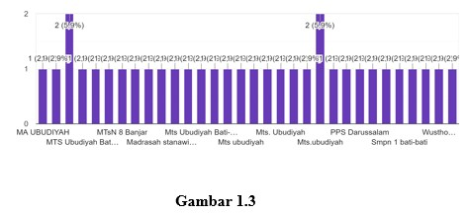

- Students of the Department of Religious Sciences (IIK)
Students of class XII majoring in Religious Sciences in the class have 41 students, 14 male students and 27 female students. 1 student from the Dayak tribe, 1 student from the Bugis ethnic group and 3 from the Javanese ethnic group and the rest from the Banjarese ethnic group. The average age of students in this class is about 18 years and reside not too far from the madrasa. Then their educational background is from junior high school, about 1 student, the rest are from Madrasah Tsanawiah and Pondok Pesantren. See the diagram below:
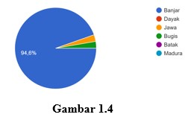
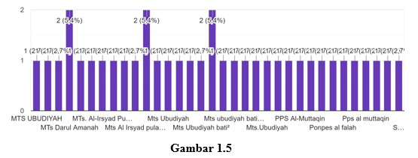
- Students in interaction
Bilingualism Interaction is a linguistic condition that arises as a result of language contact in the communication process. Jendra's statement can be concluded that language contact that occurs in a bilingual society allows someone to do code switching or code mixing in the communication process.
Code-switching is one aspect of language dependence in a bilingual or multilingual society. This means that in a bilingual or multilingual community, a speaker can use various codes in his speech according to the situation and aspects surrounding it.
Code-switching is when a speaker intentionally changes the language code he is currently using for some reason. In line with this opinion, Pietro stated that code-switching is the use of more than one language by communicants to execute a speech act.
Code mixing occurs when a speaker uses a language dominantly, supporting an utterance inserted with other language elements. This is usually related to the speaker's characteristics, such as social background, education level, and religious taste. Usually, the prominent feature is in the form of a relaxed or informal situation, but it can also occur due to language limitations. Expressions in that language have no equivalent, so there is a compulsion to use another language, even though it only supports one function.
Code-switching and code-mixing are sociolinguistic phenomena that have similarities. Therefore, the factors driving the occurrence of these two events are also challenging to distinguish and often overlap. Some experts also give these factors vary. There are several reasons why someone bilingual does code-switching. Some of these reasons include 1) quoting someone's opinion; 2) affirmation of group identity or solidarity; 3) entry or exit of a person from a conversation; 4) raising social status; 5) demonstrating language skills".
The theory of symbolic interaction according to Cooley and Mead assumes that the "self" arises because of communication. Individual adaptation to the outside world is connected through the communication process. There are three main principles of symbolic interaction theory, namely meaning, language, and thought. According to Bumer, language is a source of meaning. Meanwhile, meaning is a construction of social reality. Thought plays a role between the two.
Communication is delivering messages or interactions from the sender to the receiver. Therefore, there must be feedback between the communicator and the communicant. Likewise, education requires good communication so that what is conveyed, in this case, the subject matter, by the communicator (teacher) to the communicant (student), can be digested optimally so that the educational goals to be achieved can be realized.
Communication can be concluded as a contact relationship between humans, individuals, and groups, because in everyday life, whether we realize it or not, communication is part of human life. Even since humans are born, they have communicated with their environment. The first movement and cry when he was born is a sign of communication.
- Students' use of language
- Arabic Language
Students and teachers use Arabic in learning interactions. Here is an example:
- م: حيّا نبدأ بقراءة بسملة
ط: بسم الله الرّحمان الرّحيم
م: أيّها الطلاب و الطالبات كيف حالكم؟
ط: الحمد للّله بخير، و أنتم ؟
م: أنا بخير أيضا
م: ماذ درسنا اليوم ؟
Apa artinya ?
M: Apa pelajaran kita hari ini. ((02)3E07092021).
- Banjar Language
Examples of teacher interactions using Banjarese are as follows.
- G: kalo ada bukunya coba buka bukunya.
G: Bujur lah tulisan nya?
M: Bujur pa ((02)3E07092021).
- Indonesian Languange
language Indonesian examples of its use, namely.
- G:Serius Panji
M: Kata depan dinamakan sebagai man'ut atau maushub
G: khalas, sambung Ani meriyati silahkan sambung.
G: Ani mana orangnya Ani, bapa belum liat.ya silahkan
M: Sedangkan dinamakan naat atau sifat. Naat mengikuti man'ut apabila man'ut... contohnya fi qaryati maydanun. ((06)2D14102021).
- English Language
Examples of the use of English as follows.
- G: siap, stand up please all, هم جماعة, semua berdiri, baik الآن لكم جامعا assalamualaikum wr.wb.
M: waalaikumsalam wr.wb. ((09)2A25112021).
- Java Language
This is an example of the use of the Java language in the interaction, viz.
- G: شرب الماء apa artinya?
M: Minum air
G: ngombe banyu
M: apa itu pa ?
G: ya minum air tadi
M: ouh inggih pa ((06)2D14102021).

Table 1
Frequency Distribution
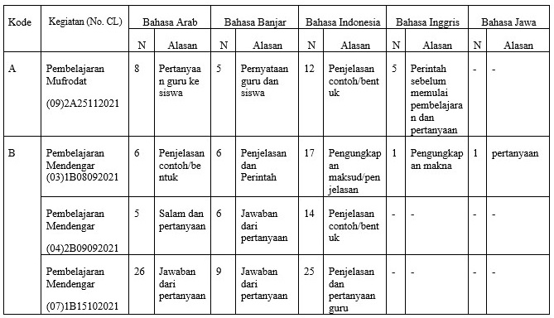
of Students' Language Use in Arabic Language Learning

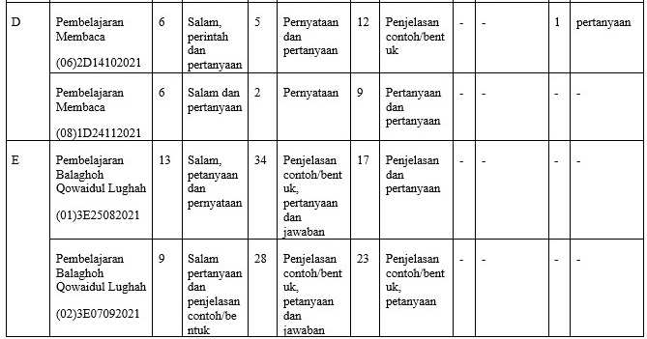

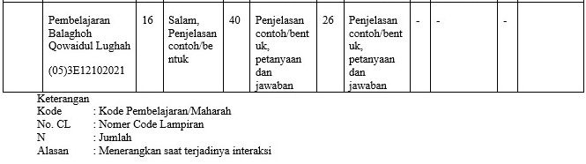

- Interaction Patterns of Speech Exchange
In every event of speaking interaction between humans, there is a transfer of information or messages from the participants. The units of information in an interactive discourse are called exchanges. Exchange has a relationship with speech. An exchange consists of two or more utterances. An exchange structure can be composed of the dimensions of the order of appearance of the elements of initiation (I), reinitiation (Ri). response (T), and feedback (B).
Pattern communicationconsists of three kinds, namely:
      - One-way communication pattern is of delivering messages from the communicator to the communicant, either using or without media, without any feedback from the communicant. In this case, the communicant acts as a listener only.
      - The pattern of two-way or reciprocal communication (two-way traffic communication), namely, the communicator and the communicant, becomes interchangeable in carrying out their functions. In the first stage, communicators become communicants and alternate functions in the next step.
      - Multi-way communication patterns, namely communication patterns that occur in one group, where more communicators and communicants will exchange ideas dialogically.
This study found sixteen patterns of exchange of tutoring interactions in Arabic learning interactions in the classroom. The interaction patterns are: (a) [I] pattern, (b) [I-RI] pattern, (c) [I-RI-T] pattern, (d) [I-RI-TB] pattern, (e) pattern [I-RI-TBTB], (f) pattern [I-RI-TBTB], (g) pattern [I-RI-TBTBT], (h) pattern [I-RI-TBTBTB], (i) pattern [ IT], (j) [ITB] pattern, (k) [ITBT] pattern, (l) [ITBTB] pattern, (m) [ITBTBT] pattern, (n) [ITBTBTB] pattern, (o) [ITBTBTBT] pattern , (p) pattern [ITBTBTBTB].
    - Pattern (I)
- G: ya silahkan bagi yang sudah di cermati lagi kalau ada yang salah bisa di perbaiki. (Siswa diam..) ((03)1B08092021)
    - Pattern [I-RI]
- G: nah kanapa jadi dibaca مَنِ اقْتَصَدَ yo? مَنْ asalnya imbah tu اِقْتَصَدَ kenapa jadi مَنِ اقْتَصَدَ dibacanya?
G: ada lah yang bisa manjalasakan ? ((05)3E12102021)
- Pattern [I-RI-T]
- G: kalo ada bukunya coba buka bukunya.
G: Bujur lah tulisan nya?
M: Bujur pa. ((02)3E07092021)
- Pattern [I-RI-T-B]
BerbBerbentuk akhir
- G: Kalau balagoh ini masuk bagian sastra Arab nya. (تعريف)Definisi balagoh, bukunya hanya beberapa orang saya bagi, yang lain bisa klo handak fotocopy bukunya minjam lawan kawannya.
G: Kalau mau file pdfnya kemaren saya sudah share lah ?
M: Sudah pa ..!!
G: Silahkan itu bisa aja dibuka, itulah nyaman nya wahini kada perlu ada kitab. Halaman 7 dan 8, hari ini tentang ta’rif dan pembahasannya. Nah saya nanti pengen kita mapel ini tiap minggu tatap muka khusus mapel saya saja. Saya mapel ini susah menjelaskan lewat WA/Class Room. Tapi kita tetap jaga jarak dan mematuhi protokol kesehatan jangan sampai lengah. ((01)3E25082021
- Pattern [I-RI-T-B-T]
- G: ساعدني، إمسح السبورة
G: Saya minta tolong hapuskan papan tulis
M: أنا أستاذ
G: dimana penghapusnya kadada kah ?
M: ada pa di pojok. ((01)3E25082021)
- Pattern [I-RI-T-B-T-B]
- G: Saya ini mutakallim atau kalam ?
G: Saya nya ini ?
M: Mutakallim..!!
G: kalau yang saya ucapkan ?
M: Kalam
G: nah balagah itu adalah sifat untuk apa yang saya ucapkan dan sifat untuk diri saya. Jadi ada orang berbalagoh artinya orang itu punya sifat balagoh. Ada juga kata-katanya/panderannya, nyawa ne bagus banar bepander indah banar ni urang berbalagoh karakter kalamnya berbalagah. Nah kalau kita urang banjar kyaitu. Karna dia sifat yang melekat pada pembicaraan tadi dan kepada orang yang berbicara. ((01)3E25082021)
- Pattern [I-RI-T-B-T-B-T]
- G: Kalo ilmu Bahasa lain selain balagoh ada yang tahu?
G: maksudnya cabang Ilmu Bahasa Arab selain balagoh?
M: Izin pa menjawab, Ilmu Nahwu dan Shorof
G: ya bujur itu jawabannya
M: alhamdulillah
G: pertahankan
M: siap pa. ((01)3E25082021)
- Pattern [I-RI-T-B-T-B-T-B-T]
- G: Nah kaya apa ikam di suruh kuitan basaruan kada bisa wadah paman Ali
G: Ikam pang bisa lah ?
M: Paman hari ini saruan tasmiyah
G: Kira-kira datang lah sidin ?
M: Kada...
G: kenapa kada datang sidin ?
M: Kada jelas
G: Apa yang Kada jelas?
M: Jam nya kadada dan alamatnya dimana. ((01)3E25082021)
- Pattern [I-T]
- G: Ahmad Arbani ilham
M: Hadir. ((08)1D24112021)
- Pattern [I-T-B]
- G: kata kata itu lkam harus dipilih kalo didalam bahasa Indonesia disebut apa?
M: Diksi iyalah pa ..!!
G: Ya itu Diksi. ((01)3E25082021)
- Pattern [I-T-B-T]
- G: Bebulik dulu sedikit, ilmu balagah ada berapa?
M: ada tiga
G: apa apa ja?
M: Ma’ani, Bayan dan Badi’. ((05)3E12102021)
- Pattern [I-T-B-T-B]
- G: terus siapa lagi
M:Uswatun Hasanah
G: Uswatun Hasanah oke, siapa lagi
M:Muhammad Salman
G: Oke khalas, sudah. ((06)2D14102021)
- Pattern [I-T-B-T-B-T]
- G:إجلسوا, belum sempurna duduk biasa kita sambat atau kita sebutkan apa, ijlisu maka duduk maka nyaman berarti kita harus mengucapkan alhamdulilah. Sebelum alhamdulilah apa, pas disuruh duduk harus menyambat apa, alhamdulilah bujur sudah, sebelum alhamdulilah harus? harus terimakasih, syukur kepada manusia harus terimakasih, syukur dengan alhamdulilah. Kita ulangi sekali lagi.
M:Syukron
G: oke, ya assalamualaikum wr. wb
M: waalaikumsalam wr.wb
G: Syukron
M: Syukron, alhamdulilah. ((06)2D14102021)
- Pattern [I-T-B-T-B-T-B]
- G: lain ini zadda ya zaudzu tulis tulisannya apa carii kawannya yang sama lawan itu
M: ضر -يضر
G: ya darro yadurru
M: R nya
G: kamu ajal kah atau diulah ulah kah ro nya
M: ajal
G: oh dasar mengajali dari situ jua kalau bati-bati kan diulah-ulah ro nya. ((09)2A25112021)
- Pattern [I-T-B-T-B-T-B-T]
- G : sekarang perhatikan ada pertanyaan tentang hal ini boleh tentang tulisan boleh tentang bacaan boleh tentang apapun silakan langsung aja laki-laki atau perempuan bebas aja pertanyaannya baik yang tulisannya atau bacaannya atau artinya silakan perempuannya bertanya boleh laki-lakinya boleh silakan. Katakan aja baik bacaannya atau patokannya qiroah bacaan silakan bapak minta satu aja perempuan. ya silakan namanya siapa
M: yasviennisa
G: yasviennisa apa tadi
M: kan di waqof lo
G: ya
M: misalnya ada tasydid di belakang huruf tu kayapa?
G: dalam bahasa Arab pertanyaannya kan di waqof sebaiknya tapi ada tasydid di mana
M: dibelakang. ((04)2B09092021)
- Pattern [I-T-B-T-B-T-B-T-B]
- G : fin, yang ikam tulis tu kayanya kedida bacaannya, bacaannya mana, ikam membaca kada tulisannya, nang bapa suruh itu, yang ikam tulis, yang ikam baca tulisannya. Malah bingung fin, baca ini fin 2×, baca fin
M : yang ini kah pa
G : لَااِلَهَ اِلَّا اللّٰه, ikam nulis mulai mana fin
M : mulai sini
G : baca, yang ikam tulis, baca mulai awal
M : قُلْ يَآاَيُّهَا الْكَفِرُوْنَ
G : ya terus
M : يَٓااَيُّهَاالَّذِينَ اَمَنُوْا، اِنَّ اللّٰهَ مَعَ الصَّبِيْرِيْنَ
G : ikam ja tuhuk membaca tulisan ikam, kada paham, قُلْيَا الْ , ini apa nih. ((03)1B08092021)

Table 2
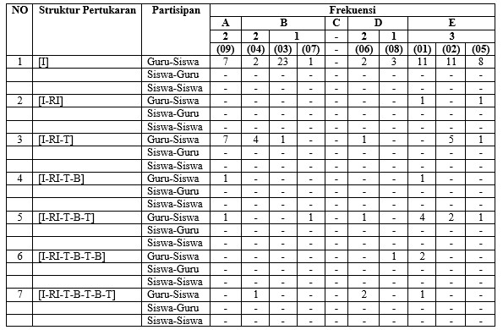
Speech Exchange Interaction Pattern

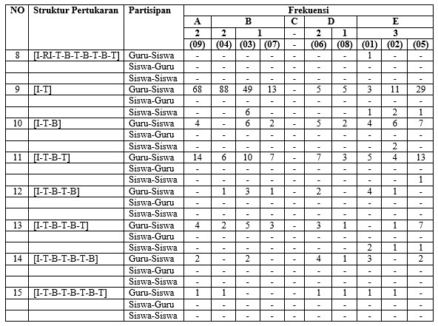

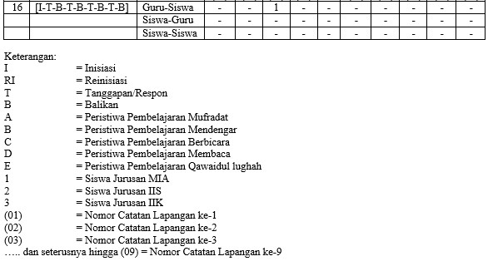

- Language Tradition of Students
Humans are social creatures and need to interact with each other. The main means of interacting is through language. Language is alive as long as there are speakers, because language is used to communicate various ideas, feelings and desires. In other words, when communicating, humans use their language for various functions, such as conveying information, asking questions, ordering, giving appreciation, expressing disappointment, and so on.
Language cannot be separated from culture, because the relationship between the two is very close. Language merges with the people who use it and own it. Because language develops according to the needs and characteristics of culture, each language reflects the culture of the people who use it. Language is part of the complex system of values, habits, and beliefs that make up a culture. Language is a form of cultural behavior, therefore language is easy to understand and use in accordance with agreed standards and is followed by certain community groups.
One of the basic concepts of using language is discourse in communication, both spoken and written. The use of language can be in the form of conversation, discussion, question and answer, and so on. The use of such language exists in communication situations. The communication situation involves several components in the form of delivering messages which can be speakers or writers, recipients of messages in the form of listeners or readers. The meaning of the message or code is linguistic symbols, while the channel is a means, and the context includes everything that is in the communication event. The use of language in communication must be accompanied by context. Therefore, one of the attention points of discourse analysis is text and context.
Almost all parts of human life are covered by language so that language is an inseparable part of the development of human culture. All activities carried out by humans in their lives cannot be separated from the elements of language in them. The use of language cannot be separated from the socio-cultural context of the speaking community. Besides being a social phenomenon, language is also a cultural phenomenon.
It is no different from humans as social beings, which in essence will always change, so culture is dynamic and will always change slowly. Why do people always change? Because if humans are not able to adapt to changing circumstances, they are not expected to survive. Likewise, the local culture has existed for hundreds of years. Slowly but surely, directly or indirectly, a culture will experience changes due to the entry of new cultural elements. Therefore, the following will discuss some important concepts related to cultural acculturation or mixing and the idea of cultural assimilation or cultural assimilation.
Humans and culture have a dialectical relationship. The purpose of creating culture by humans is as a basis or guide for human life. Culture exists because humans created it and humans are conditioned to live in the midst of the culture they created. Van Peursen stated that culture is the sediment of human activities and works. As the "sediment" of human activities and creations, of course, culture at least also represents humans as creators.
Budhiono found that one of the local cultures, namely proverbs, contains values, teachings, and good advice so that it can strengthen character. The oral culture of the community in the form of proverbs contains values ​​so that it can be used as a guide in social life. The existing culture can shape character and will develop in society so that it will indirectly build a more moral and civilized society.
This student's language tradition is student communication in the classroom, when learning Arabic always repeats words/sentences. So that it becomes a habit for students to pronounce these words/sentences.
The results of this study show students' language traditions in the classroom by displaying the results of three majors, namely, Mathematics in Natural Sciences (MIA), Social Sciences (IIS), and Religious Sciences (IIK).
In the MIA department, some words are always spoken when learning Arabic in class. This example of the word “Bujur lah pa” is contained in the attachment to the interaction field note number 3 ((03)1B08092021) learning events Hear students say three times, then in the attachment to the interaction field note number 7 ((07)1B15102021) learning events Hear students say four times and in the attachment to the interaction field note number 8 ((08)1D24112021) learning events Reading students say three times. From the results of the researcher's interviews with students majoring in MIA, students mentioned several reasons for saying these words. That is; because students feel doubtful about their own answers, students are afraid of being wrong in answering, and want to get a response from the teacher about right or wrong for the answers that students mention.
Furthermore, in the IIS department there are words that are often spoken when learning Arabic in class. This example of the word “Insya Allah” is spoken when the teacher asks after explaining or at the end of learning Arabic. It is contained in the interaction attachment 4 ((04)2B09092021) learning events Hearing students say four times, after that it is contained in attachment 6 ((06)2D14102021) learning events Reading students saying 2 times, and then also in the interaction attachment 9 ((09) 2A25112021) learning events Mufradat students say 2 times. The results of researcher interviews with students majoring in IIS, students said that saying the word was because of the way Islam applies it in daily life, students said that to look for safety so as not to be caught understanding or not understanding, and one of the students said that the word “Insya Allah” means yes from themselves but everything returns to Allah SWT.
Then, the IIK department also has words that are often spoken when learning Arabic in class. Like the words “Izin bertanya/izin menjawab” this is often used by students when they want to answer the teacher's questions in learning Arabic. The word is contained in field notes interaction 1 (01)3E25082021) Qowaid lughah learning event students say seven times, for field interaction notes in Appendix 2 ((02)3E07092021) students say Qowaid lughah learning event five times, and from field interaction notes in Appendix 5 ((05)3E12102021) regarding the Qowaid lughah learning event, students say it seven times. The results of interviews with students majoring in IIK, students said that the word “Izin bertanya/izin menjawab” was said for several reasons. That is; students said it was because of politeness when asking, other students said it was because they felt it was still unclear in the teacher's explanation, and students said it was because they asked when the teacher was still explaining the lesson.
Conclusion
Based on the results of the analysis and interpretation of research data on Ethnography of Communication in Arabic Language Learning in Students of Ma Ubudiyah Bati-Bati, it could be concluded as follows: (a) Students of Madrasah Aliyah Ubudiyah Bati Bati majoring in Natural Sciences Mathematics (MIA), Social Sciences (IIS), and Religious Sciences (IIK), the three majors used 5 languages ​​in learning Arabic, namely; Arabic, Banjarese, Indonesian, English, and Javanese. The reason for using these 5 languages ​​was to make it fun to know another language, even when learning Arabic; and (b) Interaction pattern exists (I) Initiation (RI) Reinitiation (T) Response (B) Return. There were 16 patterns of interaction speech used. That were, (1) pattern [I], (2) pattern [I-RI], (3) pattern [I-RI-T], (4) pattern [I-RI-TB], (5) pattern [I -RI-TBT], (6) [I-RI-TBTB] pattern, (7) [I-RI-TBTBT] pattern, (8) [I-RI-TBTBT] pattern, (9) [IT] pattern, (10) pattern [ITB], (11) pattern [ITBT], (12) pattern [ITBTB], (13) pattern [ITBTBT], (14) pattern [ITBTBTB], (15) pattern [ITBTBTBT], (16 ) pattern [ITBTBTBTB]. The [IT] pattern most dominates in Arabic learning interactions. Produced this pattern more from teachers to students because in it there were questions and answers, for students to students there were only a few because they didn't have much time to talk to their friends in class when learning Arabic. (c) From the results of the analysis of interactions that occured in learning Arabic, the researchers found 3 words that were often spoken when learning took place until students became accustomed to saying them. That is; “Bujur lah pa”, “Insya Allah”, and “Izin bertanya/izin menjawab”.

REFERENCES
الإسلام, سعيد حوى. دراسة منهجة حول الأصول الثلاثة. الطبعة الثالثة. دم: دن, 1981.
Azeharie, Suzy. “Pola Komunikasi Antara Pedagang Dan Pembeli Di Desa Pare, Kampung Inggris Kediri” 7, no. 2 (December 2, 2015): 207–223.
Beta, Pancan, Rinni Salvia, and Besse Herdiana. “Etnografi Komunikasi Tata Cara Bertutur Masyarakat Suku Padoe.” Jurnal Onoma: Pendidikan, Bahasa, dan Sastra 6, no. 1 (May 30, 2020): 527–532.
Darmawan, Kiki Zakiah. “Penelitian Etnografi Komunikasi: Tipe Dan Metode.” Mediator: Jurnal Komunikasi 9, no. 1 (June 10, 2008): 181–188.
Eminda Sari, Ni Wayan, and Ida Ayu Made Wedasuwari. “PILIHAN BAHASA SISWA KELAS XI IPA2 SMA (SLUA) 1 SARASWATI DENPASAR” 3, no. 2 (September 2014): 40–47.
Emzir. Metodologi Penelitian Pendidikan: Kuantitatif Dan Kualitatif. Jakarta: Raja Grafindo Persada, 2008.
Gede Paramita, Ida Bagus, and Ida Ayu Devi Arini. “TRADISI MESATUA SEBAGAI MEDIA KOMUNIKASI PENANAMAN KARAKTER ANAK” 1, no. 1 (November 7, 2020): 16–25.
Genzuk, Michael. “A Synthesis of Ethnographic Research” (n.d.): 11.
Haryanti, Eka. “PENGGUNAAN BAHASA DALAM PERSPEKTIF TINDAK TUTUR DAN IMPLIKASINYA BAGI PENDIDIKAN LITERASI.” Jurnal TAMBORA 3, no. 1 (February 21, 2019): 21–26.
Istiyanto, S. Bekti, and Wiwik Novianti. “Etnografi Komunikasi Komunitas Yang Kehilangan Identitas Sosial Dan Budaya Di Kabupaten Cilacap.” Jurnal Kajian Komunikasi 6, no. 1 (June 29, 2018): 64.
Jati, Tri Mastyo. Pengantar (Metode) Penelitian Bahasa. Yogyakarta: Carasvati books, 2007.
Jendra, M.I.I. Sociolinguistics. Yogyakarta: Graha Ilmu, 2001.
Joko, Sujana, and Rustono Farady Marta. “Etnografi Komunikasi Pada Tiga Generasi Anggota Perkumpulan Marga Ang Di Bagansiapi-Api.” KOMUNIKATIF : Jurnal Ilmiah Komunikasi 6, no. 1 (December 11, 2017): 51–59.
Kasim, Mohamad Rozi. “ETNOGRAFI KOMUNIKASI ORANG ASLI JAKUN” 14, no. 1 (January 1, 2021): 21‒44.
Lestari, Seli Dewi, and S. Bekti Istyanto. “POLA KOMUNIKASI GURU DAN SISWA BERBASIS PENDIDIKAN KARAKTER DENGAN PENERAPAN MUTU BAHASA METODE SENTRA (Studi Di SDIT Harapan Bunda Purwokerto).” JOURNAL OF SCIENTIFIC COMMUNICATION (JSC) 2, no. 1 (April 30, 2020). Accessed June 7, 2022. http://www.jurnal.untirta.ac.id/index.php/jsc/article/view/7873.
Leuape, Emanuel S, and Susanne Dida. “DIALETIKA ETNOGRAFI KOMUNIKASI EMIK-ETIK PADA KAIN TENUN.” Jurnal Kajian Komunikasi 5, no. 2 (December 28, 2017): 147.
Mudjiyanto, Bambang. “Metode Etnografi Dalam Penelitian Komunikasi, Komunikasi Massa” 5 (2009): 79–83.
Nur Inah, Ety. “PERAN KOMUNIKASI DALAM INTERAKSI GURU DAN SISWA” 8, no. 2 (July 2, 2015): 150–167.
Nurhidayah, Yayah. “Pola Komunikasi Perempuan Pesisir: Studi Etnografi Komunikasi.” Communicatus: Jurnal Ilmu komunikasi 1, no. 2 (June 25, 2019): 89–108.
Nurul Azhar, Iqbal. Sosiolinguistik Teori Dan Praktik. Surabaya: Lima-lima Jaya, 2011.
Rahmah, Siti. “POLA KOMUNIKASI KELUARGA DALAM PEMBENTUKAN KEPRIBADIAN ANAK.” Alhadharah: Jurnal Ilmu Dakwah 17, no. 33 (January 2, 2019): 13.
Rifa’i, M. “Etnografi Komunikasi Ritual Tingkeban Neloni Dan Mitoni Studi Etnografi Komunikasi Bagi Etnis Jawa Di Desa Sumbersuko( )Kecamatan Gempol Kabupaten Pasuruan.” ETTISAL Journal of Communication 2, no. 1 (June 1, 2017): 27.
Rohmani, Siti, Amir Fuady, and Atikah Anindyarini. “ANALISIS ALIH KODE DAN CAMPUR KODE PADA NOVEL NEGERI 5 MENARA KARYA AHMAD FUADI” 2 (2013): 1–16.
Setyawan, Eko, and Sarwiji Suwandi. “Representasi Budaya Lokal dalam Buku Ajar Siswa SMA.” Briliant: Jurnal Riset dan Konseptual 7, no. 1 (February 22, 2022): 35–49.
Setyo Dewi, Yuli Ani. “KORELASI EFEKTIVITAS KOMUNIKASI DAN LATAR BELAKANG ETNIS/SUKU ORANGTUA TERHADAP PERKEMBANGAN BAHASA ANAK DI RAUDLATUL ATHFAL KABUPATEN PASURUAN” 3, no. 1 (January 1, 2017).
Setyowati, Yuli. “Pola Komunikasi Keluarga Dan Perkembangan Emosi Anak (Studi Kasus Penerapan Pola Komunikasi Keluarga Dan Pengaruhnya Terhadap Perkembangan Emosi Anak Pada Keluarga Jawa).” Jurnal ILMU KOMUNIKASI 2, no. 1 (December 5, 2013). Accessed June 7, 2022. https://ojs.uajy.ac.id/index.php/jik/article/view/253.
Supriadi, Agus, Akla Akla, and J. Sutarjo. “Problematika Pengajaran Bahasa Arab Di Madrasah Aliyah.” An Nabighoh: Jurnal Pendidikan dan Pembelajaran Bahasa Arab 22, no. 02 (December 31, 2020): 211.
Triyanto, Triyanto, Fuzi Afiza Fauziyah, and Muhammad Tesar Hadi. “BAHASA SEBAGAI PENDIDIKAN BUDAYA DAN KARAKTER BANGSA.” Jurnal Salaka : Jurnal Bahasa, Sastra, dan Budaya Indonesia 1, no. 1 (January 1, 2019). Accessed June 7, 2022. https://journal.unpak.ac.id/index.php/salaka/article/view/1145.
Wicaksono, Luhur. “Bahasa Dalam Komunikasi Pembelajaran.” Jurnal Pembelajaran Prospektif 1, no. 2 (October 22, 2016). Accessed June 4, 2022. https://jurnal.untan.ac.id/index.php/lp3m/article/view/19211.
Zamzani. Kajian Sosiopragmatik. Yogyakarta: Cipta Pustaka, 2007.

سعيد حوى الإسلام, دراسة منهجة حول الأصول الثلاثة, الطبعة الثالثة. (دم: دن, 1981).
Agus Supriadi, Akla Akla, And J. Sutarjo, “Problematika Pengajaran Bahasa Arab Di Madrasah Aliyah,” An Nabighoh: Jurnal Pendidikan Dan Pembelajaran Bahasa Arab 22, No. 02 (December 31, 2020): 211.
Luhur Wicaksono, “Bahasa Dalam Komunikasi Pembelajaran,” Jurnal Pembelajaran Prospektif 1, No. 2 (October 22, 2016), Accessed June 4, 2022, Https://Jurnal.Untan.Ac.Id/Index.Php/Lp3m/Article/View/19211.
Yuli Ani Setyo Dewi, “Korelasi Efektivitas Komunikasi Dan Latar Belakang Etnis/Suku Orangtua Terhadap Perkembangan Bahasa Anak Di Raudlatul Athfal Kabupaten Pasuruan” 3, No. 1 (January 1, 2017).
Yayah Nurhidayah, “Pola Komunikasi Perempuan Pesisir: Studi Etnografi Komunikasi,” Communicatus: Jurnal Ilmu Komunikasi 1, No. 2 (June 25, 2019): 89–108.
S. Bekti Istiyanto And Wiwik Novianti, “Etnografi Komunikasi Komunitas Yang Kehilangan Identitas Sosial Dan Budaya Di Kabupaten Cilacap,” Jurnal Kajian Komunikasi 6, No. 1 (June 29, 2018): 64.
Pancan Beta, Rinni Salvia, And Besse Herdiana, “Etnografi Komunikasi Tata Cara Bertutur Masyarakat Suku Padoe,” Jurnal Onoma: Pendidikan, Bahasa, Dan Sastra 6, No. 1 (May 30, 2020): 527–532.
Mohamad Rozi Kasim, “Etnografi Komunikasi Orang Asli Jakun” 14, No. 1 (January 1, 2021): 21‒44.
Kiki Zakiah Darmawan, “Penelitian Etnografi Komunikasi: Tipe Dan Metode,” Mediator: Jurnal Komunikasi 9, No. 1 (June 10, 2008): 181–188.
Michael Genzuk, “A Synthesis Of Ethnographic Research” (N.D.): 11.
M. Rifa’i, “Etnografi Komunikasi Ritual Tingkeban Neloni Dan Mitoni Studi Etnografi Komunikasi Bagi Etnis Jawa Di Desa Sumbersuko( )Kecamatan Gempol Kabupaten Pasuruan,” Ettisal Journal Of Communication 2, No. 1 (June 1, 2017): 27.
Emzir, Metodologi Penelitian Pendidikan: Kuantitatif Dan Kualitatif (Jakarta: Raja Grafindo Persada, 2008), Hal. 144.
Tri Mastyo Jati, Pengantar (Metode) Penelitian Bahasa (Yogyakarta: Carasvati Books, 2007), Hal. 43.
Ida Bagus Gede Paramita And Ida Ayu Devi Arini, “Tradisi Mesatua Sebagai Media Komunikasi Penanaman Karakter Anak” 1, No. 1 (November 7, 2020): 16–25.
Bambang Mudjiyanto, “Metode Etnografi Dalam Penelitian Komunikasi, Komunikasi Massa” 5 (2009): 79–83.
Seli Dewi Lestari And S. Bekti Istyanto, “Pola Komunikasi Guru Dan Siswa Berbasis Pendidikan Karakter Dengan Penerapan Mutu Bahasa Metode Sentra (Studi Di Sdit Harapan Bunda Purwokerto),” Journal Of Scientific Communication (Jsc) 2, No. 1 (April 30, 2020), Accessed June 7, 2022, Http://Www.Jurnal.Untirta.Ac.Id/Index.Php/Jsc/Article/View/7873.
Siti Rohmani, Amir Fuady, And Atikah Anindyarini, “Analisis Alih Kode Dan Campur Kode Pada Novel Negeri 5 Menara Karya Ahmad Fuadi” 2 (2013): 1–16.
Iqbal Nurul Azhar, Sosiolinguistik Teori Dan Praktik (Surabaya: Lima-Lima Jaya, 2011), Hal. 16-17.
M.I.I Jendra, Sociolinguistics (Yogyakarta: Graha Ilmu, 2001), Hal. 74.
Yuli Setyowati, “Pola Komunikasi Keluarga Dan Perkembangan Emosi Anak (Studi Kasus Penerapan Pola Komunikasi Keluarga Dan Pengaruhnya Terhadap Perkembangan Emosi Anak Pada Keluarga Jawa),” Jurnal Ilmu Komunikasi 2, No. 1 (December 5, 2013), Accessed June 7, 2022, Https://Ojs.Uajy.Ac.Id/Index.Php/Jik/Article/View/253.
Ety Nur Inah, “Peran Komunikasi Dalam Interaksi Guru Dan Siswa” 8, No. 2 (July 2, 2015): 150–167.
Siti Rahmah, “Pola Komunikasi Keluarga Dalam Pembentukan Kepribadian Anak,” Alhadharah: Jurnal Ilmu Dakwah 17, No. 33 (January 2, 2019): 13.
Zamzani, Kajian Sosiopragmatik (Yogyakarta: Cipta Pustaka, 2007), Hal. 41.
Ibid., Hal. 41-42.
Sujana Joko And Rustono Farady Marta, “Etnografi Komunikasi Pada Tiga Generasi Anggota Perkumpulan Marga Ang Di Bagansiapi-Api,” Komunikatif : Jurnal Ilmiah Komunikasi 6, No. 1 (December 11, 2017): 51–59.
Eka Haryanti, “Penggunaan Bahasa Dalam Perspektif Tindak Tutur Dan Implikasinya Bagi Pendidikan Literasi,” Jurnal Tambora 3, No. 1 (February 21, 2019): 21–26.
Triyanto Triyanto, Fuzi Afiza Fauziyah, And Muhammad Tesar Hadi, “Bahasa Sebagai Pendidikan Budaya Dan Karakter Bangsa,” Jurnal Salaka : Jurnal Bahasa, Sastra, Dan Budaya Indonesia 1, No. 1 (January 1, 2019), Accessed June 7, 2022, Https://Journal.Unpak.Ac.Id/Index.Php/Salaka/Article/View/1145.
Ni Wayan Eminda Sari And Ida Ayu Made Wedasuwari, “Pilihan Bahasa Siswa Kelas Xi Ipa2 Sma (Slua) 1 Saraswati Denpasar” 3, No. 2 (September 2014): 40–47.
Suzy Azeharie, “Pola Komunikasi Antara Pedagang Dan Pembeli Di Desa Pare, Kampung Inggris Kediri” 7, No. 2 (December 2, 2015): 207–223.
Emanuel S Leuape And Susanne Dida, “Dialetika Etnografi Komunikasi Emik-Etik Pada Kain Tenun,” Jurnal Kajian Komunikasi 5, No. 2 (December 28, 2017): 147.
Eko Setyawan And Sarwiji Suwandi, “Representasi Budaya Lokal Dalam Buku Ajar Siswa Sma,” Briliant: Jurnal Riset Dan Konseptual 7, No. 1 (February 22, 2022): 35–49.

